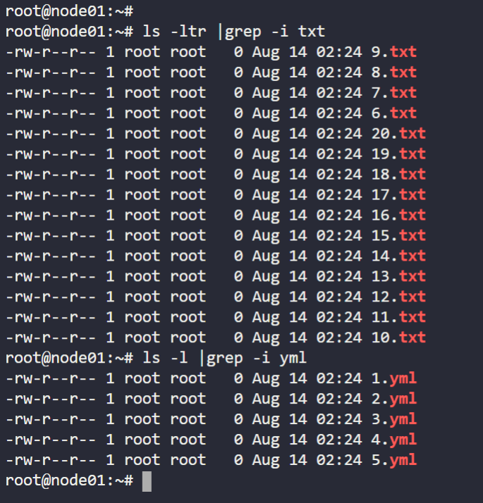

-rw-r--r-- 1 root root 0 Aug 14 02:24 9.txt

-rw-r--r-- 1 root root 0 Aug 14 02:24 8.txt

-rw-r--r-- 1 root root 0 Aug 14 02:24 7.txt

-rw-r--r-- 1 root root 0 Aug 14 02:24 6.txt

-rw-r--r-- 1 root root 0 Aug 14 02:24 5.txt

-rw-r--r-- 1 root root 0 Aug 14 02:24 4.txt

-rw-r--r-- 1 root root 0 Aug 14 02:24 3.txt

-rw-r--r-- 1 root root 0 Aug 14 02:24 2.txt

-rw-r--r-- 1 root root 0 Aug 14 02:24 20.txt

-rw-r--r-- 1 root root 0 Aug 14 02:24 1.txt

-rw-r--r-- 1 root root 0 Aug 14 02:24 19.txt

-rw-r--r-- 1 root root 0 Aug 14 02:24 18.txt

-rw-r--r-- 1 root root 0 Aug 14 02:24 17.txt

-rw-r--r-- 1 root root 0 Aug 14 02:24 16.txt

-rw-r--r-- 1 root root 0 Aug 14 02:24 15.txt

-rw-r--r-- 1 root root 0 Aug 14 02:24 14.txt

-rw-r--r-- 1 root root 0 Aug 14 02:24 13.txt

-rw-r--r-- 1 root root 0 Aug 14 02:24 12.txt

-rw-r--r-- 1 root root 0 Aug 14 02:24 11.txt

-rw-r--r-- 1 root root 0 Aug 14 02:24 10.txt

root@node01:~#

root@node01:~# ls -l |grep -i yml

-rw-r--r-- 1 root root 0 Aug 14 02:24 1.yml

-rw-r--r-- 1 root root 0 Aug 14 02:24 2.yml

-rw-r--r-- 1 root root 0 Aug 14 02:24 3.yml

-rw-r--r-- 1 root root 0 Aug 14 02:24 4.yml

-rw-r--r-- 1 root root 0 Aug 14 02:24 5.yml

root@node01:~#